**Assignment: Hello "Human"**

You are tasked to build a page that will greet whoever visits your page. If they don't tell you their name, then greet them as "human".

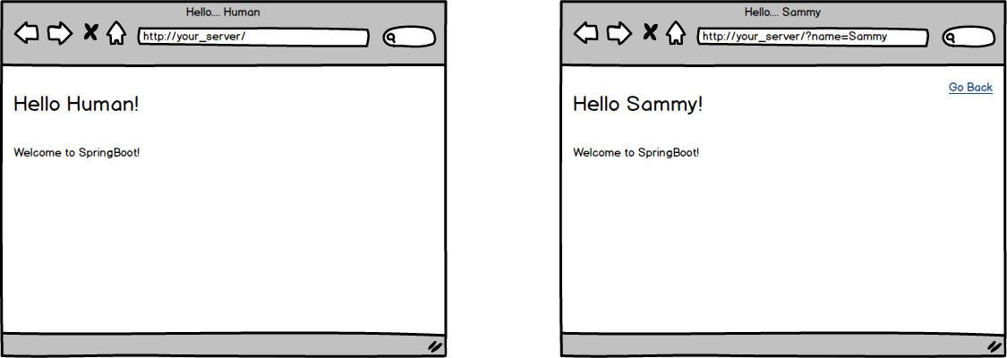

Topics:

* Query Parameters

Tasks:

* Create an app that will render a page with either a default value of "human" or with the name provided in the URL query string.

Optional Challenges:

* Can you include a "last_name" as a parameter and print out both the first and last names?